Directives In Angularjs

What are directives?

1. Directives are reusable components.
2. We can teach the new syntax to the html

Ex: <custom-name></custom-name>

1. They will give you a common functionality on the html
2. To achieve the validations
3. To build the plugins or widgets.

**Building the directives.**

1. Create a separate module with the name as ‘components’

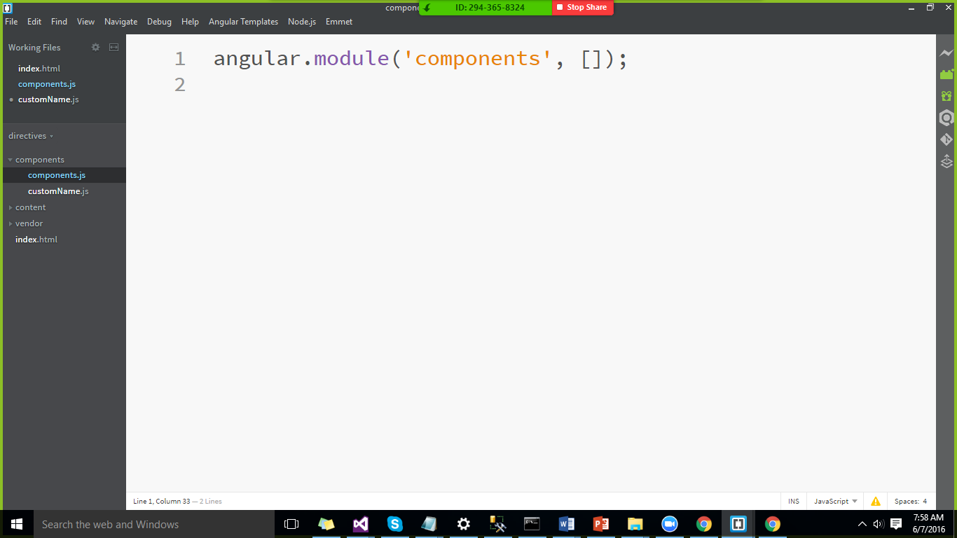

1. Create a directive with the name customName.
2. Directives will always return an object.
3. If the directive name is in camel case “customName” in the html it will be represented as

custom-name.

customName🡺custom-name

ngClick 🡺ng-click

uiView🡺ui-view

ngModel🡺ng-model

CUSTOMNAME🡺c-u-s-t-o-m-n-a-m-e

Properties of the Directives

1. Template🡺 purpose of the template is to the render the html string. It can have models, expressoins.
2. Complete Directive can be seen below.

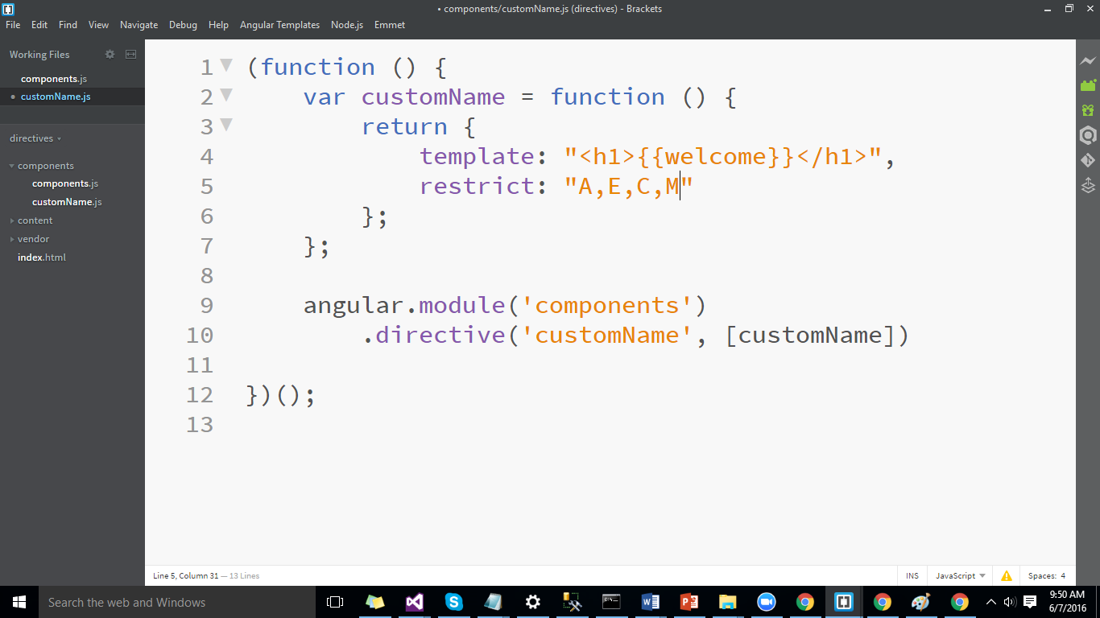

In the html the directive will be represented as below.

